4/25/2025

Disclosure of the use of AI

PDAN8411 POE Part 1

ST10036066 Zanokuhle Azania Ncube

varsity College Cape Town Campus

Contents

The disclosure of the use of AI 2

Conclusion 5

References 6

The disclosure of the use of AI

Student submission integrity is to submit work that has not been stolen or incorrectly been crediting the source author(s). It is the student’s responsibility to disclose the use of AI. Although AI such as OpenAI’s ChatGPT is not restricted for use, it is important to consider the responsibilities as well. The following document consists of images and prompt conversation hyperlinks to address the use of Large Language Models.

OpenAI’s ChatGPT was used in cases where an instruction from the POE document needed to be rephrased for better understand. Please note that assignment paper has not been uploaded on ChatGPT as there was no permission to do so.

Figure one shows a prompt asking for assistance to understand what the markdown documentation link from the POE document is and how it can be useful. The prompt’s intention is to understand how the markdown template can be used for code analysis reporting.

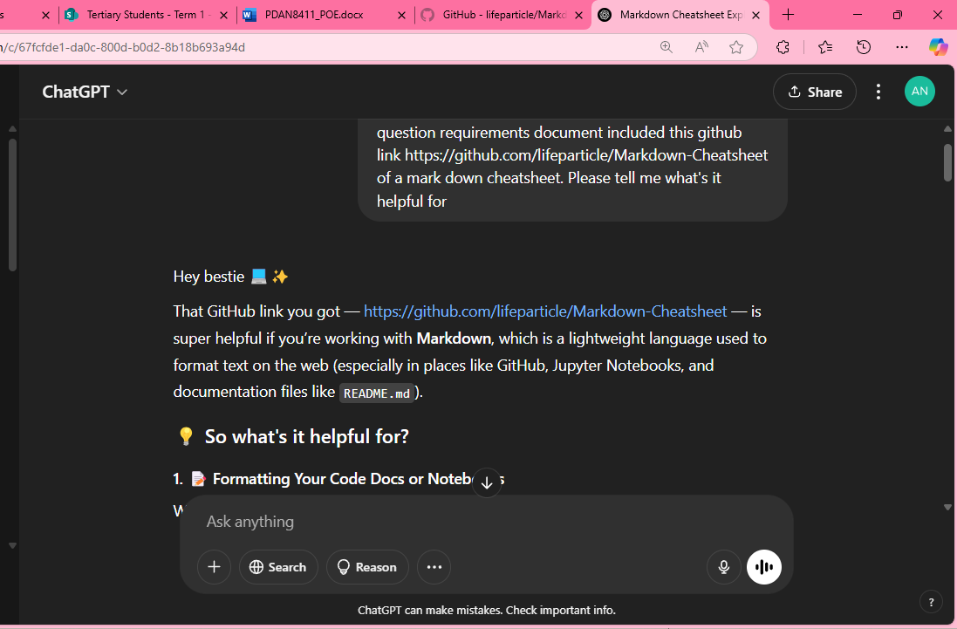

Figure OpenAI ChatGPT prompt about the use of the Markdown cheat sheet from GitHub

Conversation Link: <https://chatgpt.com/share/67fcfed9-4f98-800d-8938-0bf20200bb22>

Another occasion where OpenAI’s Large Language Model has been helpful is saving time with coming up with heading names for each markdown sections to provide a clearer and organized explanation of the code. As shown on figure two, OpenAI has been used a guide and not directly getting the solution required in the question paper. The intention of figure two’s prompt is to have an idea of what is expected at a post graduate level code file submission. For instance, labelling headings, commenting and naming conventions.

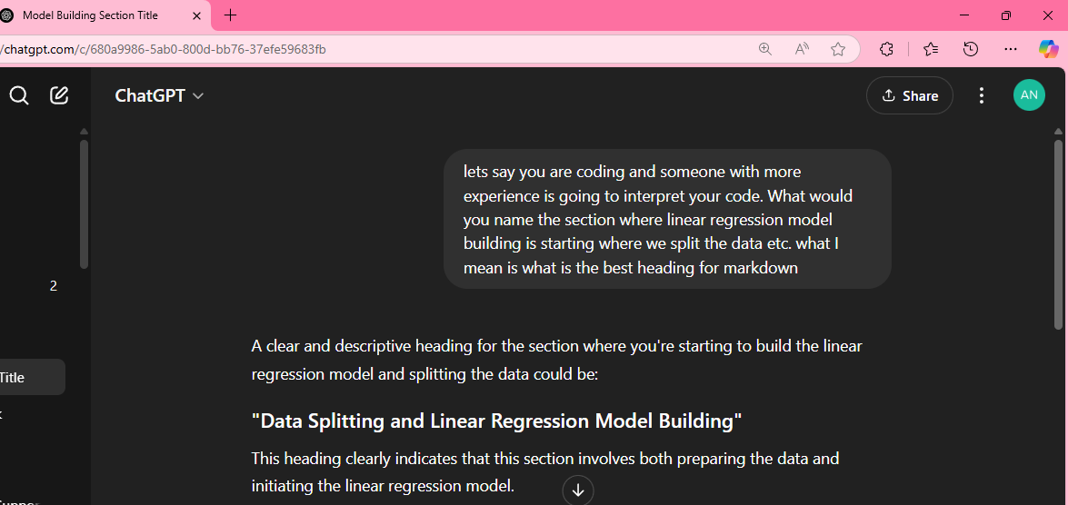

Figure a prompt and response interaction between st10036066 and OpenAI LLM

Conversation Link Accessed April 24 <https://chatgpt.com/share/680a9b55-fb48-800d-9830-c9cfdf567868>

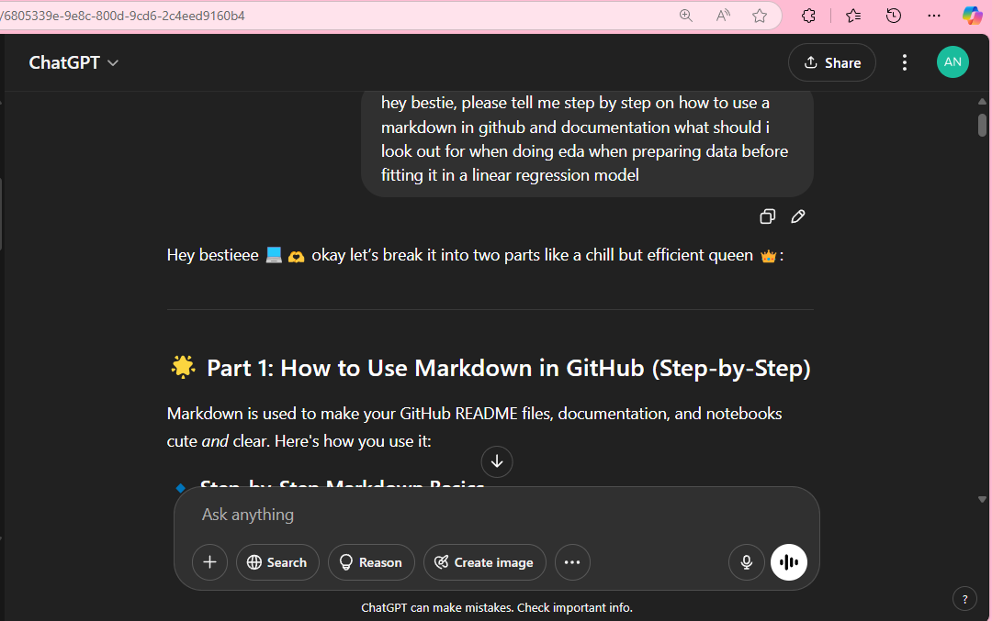

Figure How to use Markdown (Step-by-Step prompt)

Figure three shows another instance where ChatGPT was used to provided simple sentence step by step guide as to how to use markdown.

Conversation link: <https://chatgpt.com/share/680b63ed-7018-800d-8bd5-79e7a68e1c9d>

Conclusion

As much as AI tools are available to use, submission portal has an AI detection tool that ensures that students do not directly copy question, leave it for the AI tool to use then proceeding to pasting the answer as their own work. AI has been helpful in terms of breaking down question for better understanding and exploring habits that encourage post-graduate submission expectation.

References

OpenAI, 2025. *Choosing LR Model.* [Online]   
Available at: <<https://chatgpt.com/share/680b6b91-4904-800d-9415-ccf29905d716>>  
[Accessed 24 April 2025].

OpenAI, 2025. *Markdown CheatSheet Explanation.* [Online]   
Available at: <<https://chatgpt.com/share/67fcfed9-4f98-800d-8938-0bf20200bb22>>   
[Accessed 14 April 2025].

OpenAI, 2025. *Markdown Syntax Guide.* [Online]   
Available at: <<https://chatgpt.com/share/680b63ed-7018-800d-8bd5-79e7a68e1c9d>>  
[Accessed 18 April 2025].

OpenAI, 2025. *Model Building section title.* [Online]   
Available at: <<https://chatgpt.com/share/680a9b55-fb48-800d-9830-c9cfdf567868>>   
[Accessed 17 April 2025].